BestFs Algorithm Report

**Bot’s Tile Count:** 326

**Final Board Position**

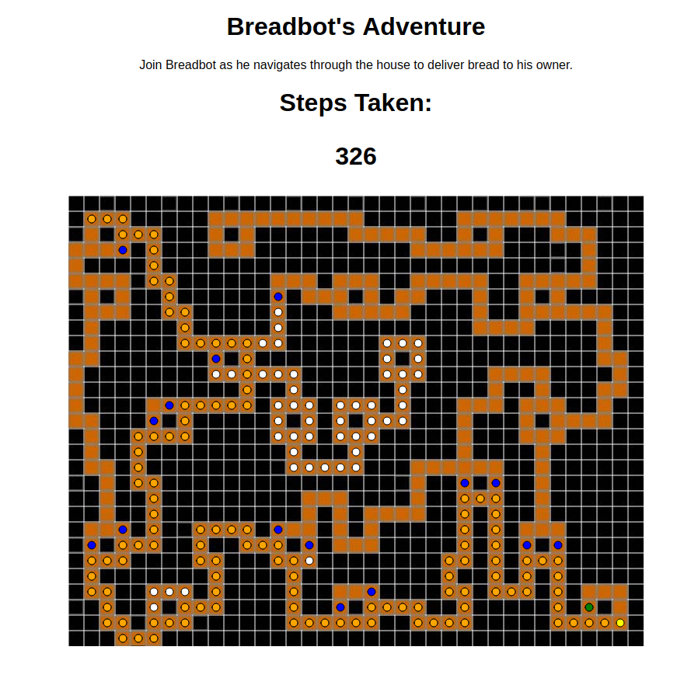

**Major Data Structures**

The algorithm created uses mainly javascript arrays in order to keep track of data. Most notably are the open list, closed list and best path list. Additionally there are junction stacks which keep track of junction decisions so that open cells can be backtracked to successfully.

The closed list consists of all path cells that have been traversed throughout the course of the bots travel. When the program is run, these cells are displayed as white dots on the maze. The open list consists of all path cells that have been discovered but not traversed to yet. These are referred to as open cells in the algorithms design. When the program is run, these cells are displayed as blue dots. Finally, the best path list consists of the shortest path of cells leading from the starting cell to the bot’s current cell. Once the bot has reached the end of the maze, the best path list will reflect the best path from the starting cell to the ending cell. When the program is run, these cells are displayed as orange dots.

It is important to note that backtracking relies on the junction stack to be able to return to the open cell it seeks. Each open cell has its own junction stack that is used to get to its position. As the bot traverses the maze and encounters junctions, it will update the junction stack of all open cells with the direction to choose when backtracking through the particular junction. While backtracking, the bot will return to junctions it had previously visited. In order to determine which direction to proceed to reach the open cell, the top of the junction stack of the open cell is used, then popped off.